
USER INTERFACE DESIGN
23CSE113
ASSIGNMENT
SUBMITTED BY
NAME | Rahul Guptha Devisetty
ROLL NO. | AV.SC.U4CSE25028
YEAR/SEM/SECTION | 1^{st Year/Sem-2/CSE-A}
CREDITS | 03

SUBMITTED TO | DR.RAJ KUMAR BATCHU
DESIGNATION | ASST.PROFFESSOR(S l. Grade)
DEPARTMENT | School of Computing

Assignment: -

Aim: - To Select a website and clone its UI as much as possible.
Website selected: https://www.vivo.com/in
Cloning done by me: -
Main Page HTML Code: -
index.html: -
<!DOCTYPE html>
<html lang="en">
<head>
<meta charset="UTF-8">
<meta name="viewport" content="width=device-width, initial-scale=1.0">
<title>SmartPhone Brand</title>

<link rel="stylesheet" href="style.css">
</head>

<body>

<header>
<div class="logo">VIVO</div>

<nav>
<a href="#">Home</a>
<a href="#">Products</a>
<a href="#">Features</a>
<a href="#">Support</a>
<a href="#">E-store</a>
<a href="#">vivo Exclusive Store</a>
<a href="#">vivo Newsroom</a>
</nav>
</header>

<section class="hero">

<div class="hero-text">
<h1>Photography Redefined</h1>

<p>
Experience flagship performance, elegant design,
and advanced mobile photography technology.
</p>

<button class="btn" id="exploreBtn">Explore Now</button>
</div>

<img
src="https://images.unsplash.com/photo-1511707171634-5f897ff02aa9?q=80&w=1000"
alt="phone">
</section>

<section class="products">

<h2 class="section-title">Latest Smartphones</h2>

<div class="product-grid">

<div class="card">
<img src="https://images.unsplash.com/photo-1598327105666-5b89351aff97?q=80&w=1000" alt="X Series">
<h3>X Series</h3>
<p>Premium flagship performance.</p>
<button class="btn">View</button>
</div>

<div class="card">
<img src="https://images.unsplash.com/photo-1512499617640-c74ae3a79d37?q=80&w=1000" alt="T Series">
<h3>T Series</h3>
<p>Professional portrait photography.</p>
<button class="btn">View</button>
</div>

<div class="card">
<img src="https://images.unsplash.com/photo-1567581935884-3349723552ca?q=80&w=1000" alt="Y Series">
<h3>Y Series</h3>
<p>Affordable and powerful smartphones.</p>
<button class="btn">View</button>
</div>

</div>
</section>

<footer>
© 2026 Smartphone Brand. All rights reserved.
</footer>

<script src="script.js"></script>

</body>
</html>

CSS File of Main Page: -

style.css: -
{
margin:0;
padding:0;
box-sizing: border-box;
font-family: Arial, sans-serif;
}
body{
background:#fff;
color:#111;
}

header{
width:100%;
padding:20px 8%;
display:flex;
justify-content:space-between;
align-items:center;
position:fixed;
top:0;
background:white;
z-index:1000;
box-shadow:0 2px 10px rgba(0,0,0,0.05);
}
.logo{
font-size:28px;
font-weight:bold;
color:#0057ff;
}

nav a{
margin-left:25px;
text-decoration:none;
color:#222;
font-weight:500;
}

.hero{
height:100vh;
background:linear-gradient(to right,#eef4ff,#ffffff);
display:flex;
align-items:center;
justify-content:space-between;
padding:0 8%;
}

.hero-text{
max-width:500px;
}

.hero-text h1{
font-size:60px;
margin-bottom:20px;
}

.hero-text p{
font-size:18px;
line-height:1.6;
color:#555;
margin-bottom:30px;
}

.btn{
padding:14px 30px;
background:#0057ff;
color:white;
border:none;
border-radius:30px;
cursor:pointer;
font-size:16px;
}

.hero img{
width:450px;
animation:float 3s ease-in-out infinite;
}

@keyframes float{
0%{
transform:translateY(0);
}
50%{
transform:translateY(-15px);
}
100%{
transform:translateY(0);
}
}

.products{
padding:100px 8%;
}

.section-title{
text-align:center;
font-size:40px;
margin-bottom:50px;
}

.product-grid{
display:grid;
grid-template-columns:repeat(auto-fit,minmax(250px,1fr));
gap:30px;
}

.card{
background:#fff;
border-radius:20px;
padding:25px;
text-align:center;
box-shadow:0 5px 20px rgba(0,0,0,0.08);
transition:0.3s;
}

.card:hover{
transform:translateY(-10px);
}

.card img{
width:100%;
max-width:220px;
}

.card h3{
margin:20px 0 10px;
}

.card p{
color:#666;
margin-bottom:15px;
}

footer{
background:#111;
color:white;
padding:40px 8%;
text-align:center;
margin-top:50px;
}

@media(max-width:768px){

.hero{
flex-direction:column;
text-align:center;
justify-content:center;
}

.hero img{
width:300px;
margin-top:40px;
}

.hero-text h1{
font-size:42px;
}

nav{
display:none;
}
}

JavaScript Code:-

script.js:-
// Explore button action
const exploreBtn = document.getElementById("exploreBtn");

exploreBtn.addEventListener("click", () => {
document.querySelector(". products").scrollIntoView({
behavior: "smooth"
});
});

Login Page HTML Code:-

login.html:-
<!DOCTYPE html>
<html lang="en">
<head>
<meta charset="UTF-8">
<meta name="viewport" content="width=device-width, initial-scale=1.0">
<title>Login</title>

<style>
*{
margin:0;
padding:0;
box-sizing:border-box;
font-family:Arial, sans-serif;
}

body{
display:flex;
justify-content:center;
align-items:center;
height:100vh;
background:linear-gradient(135deg,#0057ff,#6ea8ff);
}

.login-box{
background:#fff;
padding:40px;
width:350px;
border-radius:15px;
box-shadow:0 5px 20px rgba(0,0,0,0.2);
}

.login-box h2{
text-align:center;
margin-bottom:25px;
}

.input-box{
margin-bottom:15px;
}

.input-box input{
width:100%;
padding:12px;
border:1px solid #ccc;
border-radius:8px;
outline:none;
}

.btn{
width:100%;
padding:12px;
border:none;
background:#0057ff;
color:white;
border-radius:8px;
cursor:pointer;
font-size:16px;
}

.btn:hover{
background:#0040c1;
}

.register{
text-align:center;
margin-top:15px;
}

.register a{
text-decoration:none;
color:#0057ff;
}
</style>
</head>
<body>

<div class="login-box">
<h2>Login</h2>

<form>
<div class="input-box">
<input type="email" placeholder="Email" required>
</div>

<div class="input-box">
<input type="password" placeholder="Password" required>
</div>

<button type="submit" class="btn">Login</button>
</form>

<div class="register">
<p>Don't have an account? <a href="#">Register</a></p>
</div>
</div>

</body>
</html>

Login Page CSS: -
login.css: -
*{margin:0;
padding:0;
box-sizing: border-box;
font-family: Arial,
sans-serif;
}
body{
display:flex;
justify-content:center;
align-items:center;
height:100vh;
background:linear-gradient(135deg,#0057ff,#6ea8ff);
}
.login-box{
background:#fff;
padding:40px;
width:350px;
border-radius:15px;
box-shadow:0 5px 20px rgba(0,0,0,0.2);
}
.login-box h2{
text-align:center;
margin-bottom:25px;
}

.input-box{
margin-bottom:15px;
}
.input-box input{
width:100%;
padding:12px;
border:1px solid #ccc;
border-radius:8px;
outline:none;
}

.input-box input:focus{
border-color:#0057ff;
}
.btn{
width:100%;
padding:12px;
border:none;
background:#0057ff;
color:white;
border-radius:8px;
cursor:pointer;
font-size:16px;
}

.btn:hover{
background:#0040c1;
}
.register{
text-align:center;
margin-top:15px;
}

.register a{
text-decoration:none;
color:#0057ff;
font-weight:bold;
}

Output: -
Cloned Home Page: -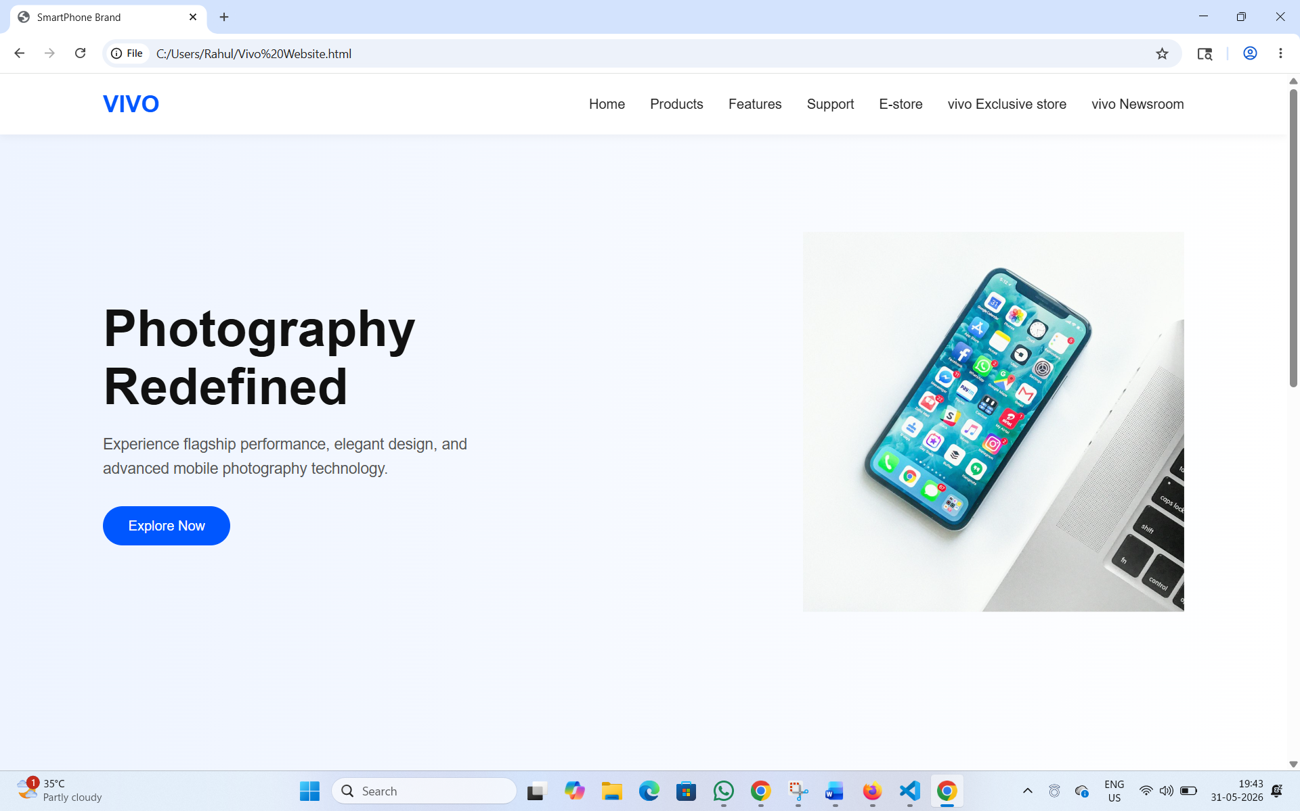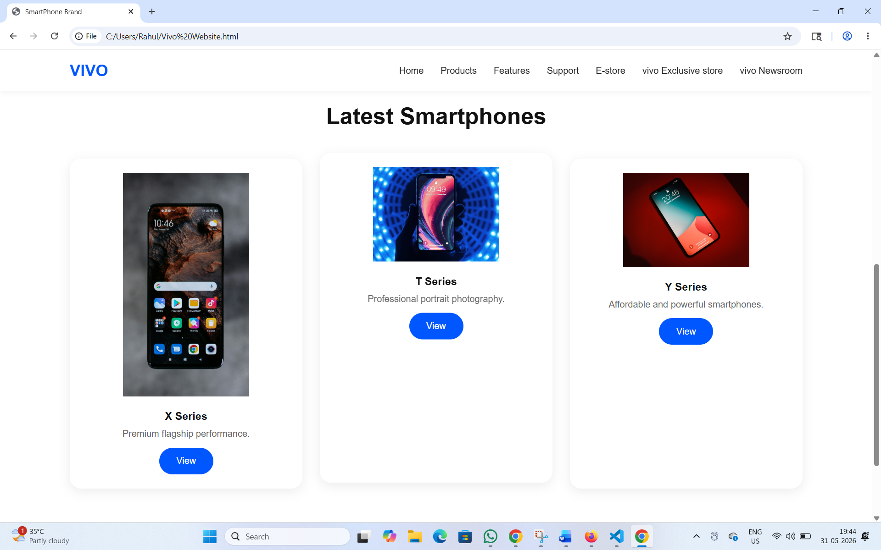

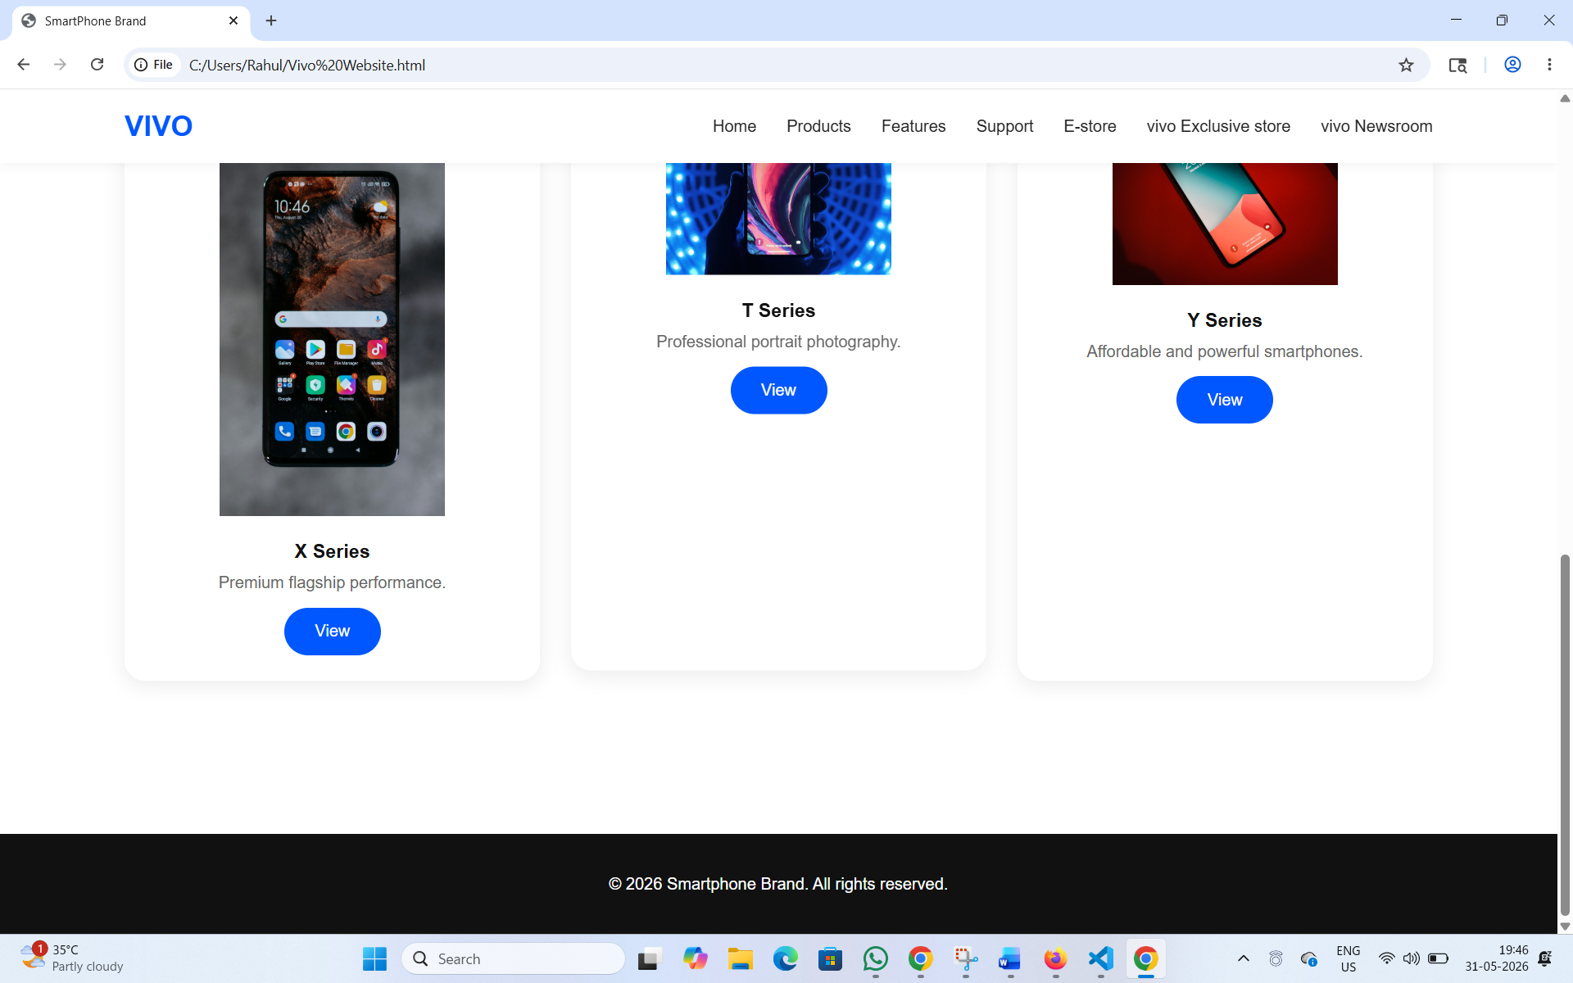

Explanation of Important Elements:
In this project, I used several important HTML, CSS, and JavaScript elements and concepts to make the website look similar to the official Vivo website, and also to make it interactive and user-friendly. The project mainly focuses on front-end web development concepts such as layout design, multimedia integration, dynamic content generation, and event handling.

1. Document Setup & Global Styles

The HTML Head
HTML
<meta name="viewport" content="width=device-width, initial-scale=1.0"/>
This line is crucial. It tells mobile browsers to scale the website to fit the actual width of the device screen, preventing mobile phones from rendering the site like a zoomed-out desktop page.

The Global CSS Reset (*)
CSS
*{
margin: 0;
padding: 0;
box-sizing: border-box;
font-family: Arial, sans-serif;
}
- margin: 0; padding: 0;: Different browsers have different default spacing for headings, paragraphs, and lists. This zeroes them out so you start with a clean slate.
- box-sizing: border-box;: By default, adding padding or borders to an element makes it wider. border-box forces the browser to include padding and borders inside the element's total declared width/height, making layout calculations vastly easier.

2. Header & Navigation Component
HTML
<header>
<div class="logo">VIVO</div>
<nav>...</nav>
</header>

The CSS Mechanics:
CSS
header {
width: 100%;
padding: 20px 8%;
display: flex;
justify-content: space-between;
align-items: center;
position: fixed;
top: 0;
background: white;
z-index: 1000;
box-shadow: 0 2px 10px rgba(0,0,0,0.05);
}
- position: fixed; top: 0;: This pins the header to the top of the browser viewport. As the user scrolls down the page, the header stays visible at the top.
- display: flex; justify-content: space-between;: Using Flexbox handles layout automatically. space-between pushes the logo to the far left and the navigation menu (nav) to the far right.
- align-items: center;: Vertically aligns the logo text and the nav links perfectly in the center of the header bar.
- z-index: 1000;: Acts like layers in Photoshop. A high z-index ensures that the header stays layered on top of all other content when scrolling.

3. The Hero Section (Intro)
The Hero section is the first thing a user sees. It splits the screen into a text block on the left and a floating smartphone image on the right.
HTML
<section class="hero">
<div class="hero-text">...</div>
<img src="..." alt="phone">
</section>

The CSS Mechanics:
CSS
.hero {
height: 100vh;
background: linear-gradient(to right, #eef4ff, #ffffff);
display: flex;
align-items: center;
justify-content: space-between;
padding: 0 8%;
}
- height: 100vh;: vh stands for Viewport Height. 100vh means this section will perfectly fill 100% of the browser window's height, creating an immersive, full-screen opening.
- linear-gradient(...): Generates a smooth background color fade transitioning from a soft, tech-style blue (#eef4ff) on the left to pure white (#ffffff) on the right.
- Flexbox: Once again, display: flex and justify-content: space-between split the screen, putting text on one side and the image on the other.

The Floating Animation
CSS
.hero img {
width: 450px;
animation: float 3s ease-in-out infinite;
}
@keyframes float {
0% { transform: translateY(0); }
50% { transform: translateY(-15px); }
100% { transform: translateY(0); }
}
This creates a premium, smooth visual effect.
- The @keyframes float defines a timeline: at 0% (start), the image is in its normal spot; at 50% (middle), it shifts up by 15 pixels along the Y-axis (translateY(-15px)); at 100% (end), it returns to normal.
- The animation property ties it together: it runs the float timeline over a duration of 3s, uses an ease-in-out timing curve to make the transition look smooth/fluid, and loops infinitely.

4. The Products Section (Grid Layout)
This section showcases a list of smartphones using modern CSS Grid.
HTML
<div class="product-grid">
<div class="card">...</div>
<div class="card">...</div>
<div class="card">...</div>
</div>

The CSS Grid Powerhouse:
CSS
.product-grid {
display: grid;
grid-template-columns: repeat(auto-fit, minmax(250px, 1fr));
gap: 30px;
}
This single rule handles responsive design automatically without needing complex alterations:
- repeat(auto-fit, ...): Tells the browser to cram as many columns into a row as will physically fit.
- minmax(250px, 1fr): Sets a rule for those columns. They can never shrink smaller than 250px wide. If there's extra space left over, they will expand equally to fill the remaining space (1fr or 1 fraction unit).
- Result: On a wide desktop, you see 3 columns. On a tablet, it drops to 2. On a mobile phone, they automatically stack into 1 column.

Card Hover Effect
CSS
.card {
transition: 0.3s;
}
.card:hover {
transform: translateY(-10px);
}
When a user hovers their mouse over a product box (:hover), the card shifts up by 10 pixels. The transition: 0.3s ensures this shift happens over a fraction of a second rather than instantly snapping, creating a tactile feel.

5. Responsive Design (Media Queries)
At the bottom of the style block, a CSS Media Query targets devices with screen widths of 768px or smaller (typically tablets and mobile phones).
CSS
@media(max-width: 768px) {
.hero {
flex-direction: column;
text-align: center;
justify-content: center;
}
.hero img {
width: 300px;
margin-top: 40px;
}
nav {
display: none;
}
}

Conclusion:
Here are the key takeaways of what this codebase achieves:
- Modern Layout Standards: By bypassing older positioning tricks and relying heavily on Flexbox (for alignment, headers, and hero layout) and CSS Grid (for the automated product layout), the code achieves robust structural integrity with very few lines of CSS.
- Built-in Responsiveness: The code elegantly scales from large desktop monitors down to mobile viewports. The layout switches effortlessly from a multi-column presentation to a single, vertically stacked column without breaking the design flow.
- Micro-Interactions & UX: Subtle enhancements—like the floating animation in the hero block and the smooth elevation of the cards on hover (translateY)—transform the user experience from a static document into a premium, interactive product application.
- Production Readiness: Structurally, the separation of concerns is clean, using native HTML elements semantically (<header>, <section>, <footer>

"THE END!"

